BUSINESS ONLINE BANKING OVERVIEW

NCB’s Business Online Banking is one of our secure and convenient electronic banking chan- nels that allow business customers access to their NCB accounts and the ability to execute transactions online, from anywhere in the world, at any time. This application is web based and accessed via our website www.jncb.com. With NCB Business Online Banking you may:

f Access your account and credit card balances
f View and generate account statements
f Obtain a graphical view of your inflows and outflows on your company bank accounts and credit cards
f Generate merchant statements
f Transfer funds between your own NCB Accounts
f Schedule Transfers
f Make Bill Payments to over 150 Bill Payment merchants
f Download and print transaction reports and receipts
f Make International Wire Transfers
f Make debit and credit funds transfers to Other Banks via the Automated Clearing House [ACH] and Real Time Gross Settlement [RTGS]
f Execute Batch/Bulk Wire Transfers
f Utilize payroll services
f Set recurring transfers
f Conduct password user self-administration
f Conduct cheque deposits via a scanner
f Company Self Administration

HOW TO SUBMIT YOUR APPLICATION FORM
Your application form is edit writeable and can be downloaded and saved for completion at a time that is convenient to you. Once completed you can print and submit to anyone of our branches island wide duly authenticated by your company officers along with your company stamp or seal.

ONLINE BANKING SUPPORT
Our FAQ’s and Virtual Demos located on our website www.jncb.com can be consulted for product information as well as for further assistance you may email us at e-ChannelSupport@jncb.com or call our 24*7 Customer Care Centre toll free at: 888-NCB-FIRST (622-3477) in Jamaica, 866-NCB-FIRST (622-3477) from the United States of America Canada and the Caribbean and 0-800-032-2973 from the United Kingdom and the rest of the world.
Revised September 2019

ENTITY INFORMATION
ENTITY FULL NAME
ENTITY ADDRESS
ENTITY TELEPHONE NO. |  | ENTITY TRN (IF APPLICABLE)
SECURITY ALERT - EMAIL ADDRESS |  | COMPANY EMAIL ADDRESS
ENTITY/CORPORATE LOGIN NAME (CORPORATE ID)  (A COMBINATION OF LETTERS AND NUMBERS ONLY ARE ALLOWED) |  | ENTITY DATE OF REGISTRATION / INCORPORATION  (DD / MM / YY)
ENTITY CUMULATIVE LIMIT (DAILY)  (THIS REPRESENTS THE SUM TOTAL OF THE VALUE OF ALL TRANSAC- TIONS DONE BY THE ENTITY IN A DAY) | J$  (NOT EXCEEDING J$2 BILLION)

ENTITY CLASSIFICATION:
PLEASE TICK WITH ( )

SOLE PROPRIETORSHIP

PARTNERSHIP CORPORATION

CHURCH CLUB & ASSOCIATION

LIMITED LIABILITY

OTHER

Revised September 2019

ENTITY PROFILE
APPLICATION STATUS: | NEW | AMENDMENT
NUMBER OF APPROVERS REQUIRED PER TRANSACTION: | 1 TO APPROVE | 2 TO APPROVE

APPROVER GROUPS AND TRANSACTION LIMITS
APPROVER GROUP*  (Select all that apply) | GROUP 1 | GROUP 2 | GROUP 3 | GROUP 4
APPROVER TRANSACTION LIMITS
(Select all that apply)

Note: Individual group limit should not exceed the entity limit. Additionally, the group numbers above are hierarchical (i.e. the lowest level approvers should be in Group 1).

WE HEREBY AUTHORIZE THE BANK TO DEBIT THE ACCESS FEE FROM ACCOUNT

USER OPTIONS** (Key for next page)

View Enter Approve
Enter & approve
(Limited liability companies must complete board resolution below if this option is selected)
NOTE: Only 1 of the above options may be assigned to each user. All assigned users will see all of the entity’s accounts. Administrator (Admin)
(This option allows the user to conduct administrative activities only e.g. User and transaction limit creation/modification. If required, this option may be combined with either approve or enter and approve only options above. )

USER PROFILE – ADD
NAME OF USER | USER LOGIN NAME (ID) _{(LETTERS} _{AND} NUMBERS ONLY)  USER TRN | USER EMAIL ADDRESS  * DESIGNATED COMPANY EMAIL ADDRESS | USER OPTION** | APPROVER GROUP ASSIGNED* | NCB ONLY TRANSAC- TIONS  *** | OTHER BANKS’ TRANSAC- TIONS  **** | CREDIT CARD NUMBER ONLY (First  4 and last 4 numbers of credit card only e.g.  77771234)
 | LOGIN ID: | PRIMARY:
 | TRN: | ALTERNATE:
 | LOGIN ID: | PRIMARY:
 | TRN: | ALTERNATE:
 | LOGIN ID: | PRIMARY:
 | TRN: | ALTERNATE:
 | LOGIN ID: | PRIMARY:
 | TRN: | ALTERNATE:
 | LOGIN ID: | PRIMARY:
 | TRN: | ALTERNATE:
 | LOGIN ID: | PRIMARY:
 | TRN: | ALTERNATE:
 | LOGIN ID: | PRIMARY:
 | TRN: | ALTERNATE:
 | LOGIN ID: | PRIMARY:
 | TRN: | ALTERNATE:
 | LOGIN ID: | PRIMARY:
 | TRN: | ALTERNATE:
 | LOGIN ID: | PRIMARY:
 | TRN: | ALTERNATE:
 | LOGIN ID: | PRIMARY:
 | TRN: | ALTERNATE:
 | LOGIN ID: | PRIMARY:
 | TRN: | ALTERNATE:
 | LOGIN ID: | PRIMARY:
 | TRN: | ALTERNATE:
 | LOGIN ID: | PRIMARY:
 | TRN: | ALTERNATE:
 | LOGIN ID: | PRIMARY:
 | TRN: | ALTERNATE:
Revised September 2019

USER PROFILE – DELETE
NAME OF USER USER LOGIN NAME (ID) _{(LETTERS} _{AND}
NUMBERS ONLY)
USER TRN

USER EMAIL ADDRESS
* DESIGNATED COMPANY EMAIL ADDRESS

USER OPTION**

APPROVER GROUP ASSIGNED*

NCB ONLY TRANSAC- TIONS
***

OTHER BANKS’ TRANSAC- TIONS
****

CREDIT CARD NUMBER ONLY (First
4 and last 4 numbers of credit card only e.g.
77771234)

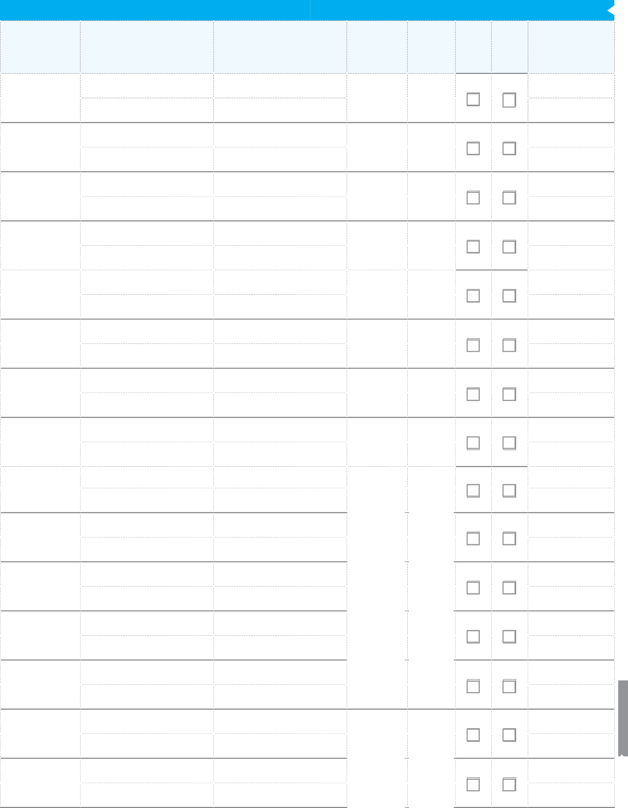
LOGIN ID: PRIMARY:

TRN: ALTERNATE:

LOGIN ID: PRIMARY:

TRN: ALTERNATE:

LOGIN ID: PRIMARY:

TRN: ALTERNATE:

LOGIN ID: PRIMARY:

TRN: ALTERNATE:

LOGIN ID: PRIMARY:

TRN: ALTERNATE:

LOGIN ID: PRIMARY:

TRN: ALTERNATE:

LOGIN ID: PRIMARY:

TRN: ALTERNATE:

LOGIN ID: PRIMARY:

TRN: ALTERNATE:

LOGIN ID: PRIMARY:

TRN: ALTERNATE:

LOGIN ID: PRIMARY:

TRN: ALTERNATE:

LOGIN ID: PRIMARY:

TRN: ALTERNATE:

LOGIN ID: PRIMARY:

TRN: ALTERNATE:

LOGIN ID: PRIMARY:

TRN: ALTERNATE:
Revised September 2019

LOGIN ID: PRIMARY:

TRN: ALTERNATE:

LOGIN ID: PRIMARY:

TRN: ALTERNATE:

NCB REMOTE CHEQUE DEPOSIT REGISTRATION ONLY (Referred to as Appendix 1 in Authority and Indemnity Form)
Revised September 2019

(IF DETAILS COMPLETED BELOW, THE NCB BUSINESS ONLINE APPLICATION FORM SHOULD BE SUBMITTED ALONG WITH AN AUTHORITY AND INDEMNITY FORM FOR NCB REMOTE CHEQUE DEPOSIT, WHICH MAY BE OBTAINED FROM YOUR BUSINESS BANKER OR BRANCH)

ACCOUNT NUMBERS TO BE LINKED TO REMOTE CHEQUE DEPOSIT: |  | ALL ACCOUNTS |  | OR SPECIFIC ACCOUNTS ONLY (LIST ACCOUNT NUMBER(S) IN TABLE BELOW):
1 |  |  | 4
2 |  |  | 5
3 |  |  | 6

User(s) to access Remote Cheque Deposit:
NAME OF USER | USER LOGIN NAME (ID) (LETTERS AND NUMBERS ONLY)  USER TRN | USER EMAIL ADDRESS  * DESIGNATED COMPANY EMAIL ADDRESS
 | LOGIN ID: | PRIMARY:
 | TRN: | ALTERNATE:
 | LOGIN ID: | PRIMARY:
 | TRN: | ALTERNATE:
 | LOGIN ID: | PRIMARY:
 | TRN: | ALTERNATE:
 | LOGIN ID: | PRIMARY:
 | TRN: | ALTERNATE:
 | LOGIN ID: | PRIMARY:
 | TRN: | ALTERNATE:

PRE-REQUISITE SOFTWARE / HARDWARE REQUIREMENTS:

- Selected Personal Computer (Laptop or Desktop) must have Internet Access (Internet Explorer 10 or higher).

- Selected Personal Computer (Laptop or Desktop) must have Adobe XI or higher.

- Selected Personal Computer (Laptop or Desktop) must have Windows 7 operating system.

- NCB Business Online Banking (Full Access Profile) and RSA Token already setup for all users of the Remote Cheque Deposit solution.

- IT Personnel (with Administrator rights) should be made available on the scheduled installation date to be agreed with NCB’s Remote Cheque Deposit Support Team.

By completing the Remote Cheque Deposit sections above and signing the NCB e-FINANCIAL SERVICES Agreement below, National Commercial Bank Jamaica Lim- ited (“the Bank”) shall accept this as your registration for the Remote Cheque Deposit service and confirmation that all the pre-requisite requirements listed above are in place and have been met.

NCB e-FINANCIAL SERVICES AGREEMENT

I/We (hereinafter being referred to as “I”, “we”, “us”, “our”) agree and acknowledge that this application, once accepted by National Commercial Bank Jamaica Limited (“the Bank”), shall be read along with the NCB e-Financial Services Terms and Conditions and the Terms and Conditions for Banking Relationship with National Commercial Bank Jamaica Limited which govern the operation of our account(s) with the Bank. We further acknowledge that we have been either been provided with a copy of these terms and conditions or have accessed them on the Bank’s website at www.jncb.com prior to opening the account(s). We understand that these terms and condition may change from time to time, that we may access a current version of the terms and conditions on the Bank’s website and that we will be notified of any changes to these terms and conditions if prior notification is required by law. We agree that if I continue to operate my account(s) or otherwise access products or services from the Bank relating to my account(s) after the effective date of the change in the terms and conditions, I will by so doing be deemed to indicate my agreement to the change(s).

In completing this application form, we may be disclosing to the Bank personal data, as defined by the Data Protection Act, 2020 relating to our officers or other persons associated with us. We understand that the Bank may process this data and the terms upon which it does so are set out in its privacy notice on its website. We also agree that the Bank may use this information in this application in order to augment and update information that it has on record or me.

AUTHORIZED SIGNATURE AUTHORIZED SIGNATURE AUTHORIZED SIGNATURE

NAME AND TITLE NAME AND TITLE NAME AND TITLE
PLEASE AFFIX COMPANY STAMP OR SEAL (WHERE REQUIRED)

BOARD RESOLUTION
(APPLICABLE ONLY WHERE “ENTER AND APPROVE” USER OPTION IS SELECTED FOR USER(S) IN THE USER PROFILE SECTION AND TRANSACTIONS ONLY REQUIRE “ONE (1) TO APPROVE”)

WE the undersigned being a Director and a Director/Secretary of the Company whose registered office is at in the parish of hereby certify that at a meeting of the Board of Directors of the Company held on the day of , 20 IT WAS RESOLVED THAT:

- The ,
[Insert Name and/Title of Authorized Officer/s]
any two Directors or a Director and the Secretary of the Company be and are hereby authorized to designate the persons who will have authority to operate the Company’s account/s at National Commercial Bank Jamaica Limited (“the Bank”) via the NCB Business Online Banking platform and the scope of the authority of such designated persons (including persons who will have access to the “Enter and Approve” User Option) by completing the NCB Business Online Banking Applica- tion Form (the “Online Banking Application Form”) duly signed by the said Authorized Officer/s, two Directors or Director and Secretary authorised in that behalf and submitting the said Online Banking Application Form to the Bank.

- The designations and instructions contained in the Application shall supersede any other instructions and designations previously given by the Company to the Bank or contained in any mandate previously given by the Company to the Bank in relation to the Company’s use of or access to the NCB Business Online Banking platform and will apply exclusively to transactions conducted through NCB Business Online Banking.

DATED the day of 20

DIRECTOR DIRECTOR/SECRETARY

PRINT NAME PRINT NAME
PLEASE AFFIX COMPANY STAMP OR SEAL (WHERE REQUIRED)
Revised September 2019

